** **

**Project Initialization and Planning Phase**

| Date | 24 April 2024 |
| --- | --- |
| Team ID | 740663 |
| Project Name | RESERVATION CANCELLATION PREDICTION |
| Maximum Marks | 3 Marks |

**Define Problem Statement :**

 Reservation Cancellation Prediction is a Binary Classification problem. Reservation Cancellation Prediction involves identifying reservations which can be cancelled based on number of factors like number of adults, number of children, type of booking, parking allotment, etc. Predictive analytics and machine learning techniques can be used to analyse large amounts of data to identify patterns of reservation cancellation. Reservation Cancellation Prediction involves use of various algorithms to analyse large datasets and identify patterns and tell apart the reservations that are going to be cancelled.

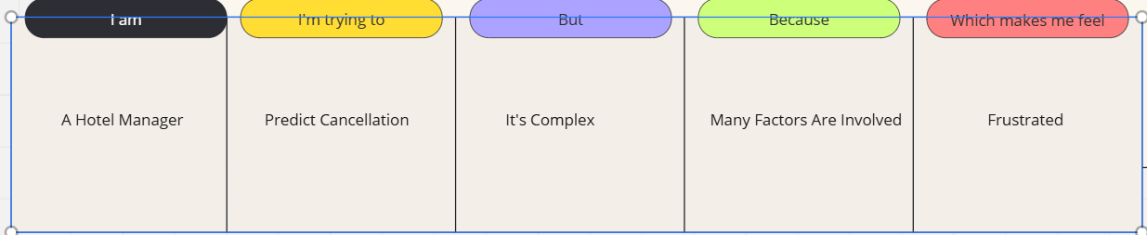

|  |  |  |  |  |  |
| --- | --- | --- | --- | --- | --- |
| **Problem**  **Statement (PS)** | **I am**  **(Customer)** | **I’m trying to** | **But** | **Because** | **Which makes me feel** |
| PS-1 | A Hotel Manager | Predict cancellation | It's complex | Many factors are involved | Frustrated |
| PS-2 | A travel agent | Reduce cancellation | It's unpredictable | Customer behaviors vary | Anxious |